roid

217, Sheikh Rashid Building

P.O Box 56272, Dubai

United Arab Emirates

Tel: +971 4 2973236 / 04 2974007

Email: uae@verbat.com

PROJECT   
PROPOSAL

**Raviz Loyalty Card**

|  |  |
| --- | --- |
| **Prepared for:**  **Mohammed Kassim** | **Submission Date:**  09 Aug 2017  **Proposal ID:** AD/BP/09082017/1343/1 |

___________________________________________________________________________________________________________________________________________  
Conﬁdentiality Notice: This Proposal is conﬁdential and contains proprietary information and intellectual property of Verbanet Technologies LLC. Neither this proposal nor any of the information contained herein may be reproduced or disclosed under any circumstances without the express written permission of Verbanet.

© 2017 by Verbanet Technologies LLC. All rights reserved. Confidential.

___________________________________________________________________________________________________________________________________________

Project Contacts

|  |  |
| --- | --- |
| Client Information | |
| Project Name | Raviz Loyalty Card App |
| Client Name | Raviz Hotels |
| Client Address |  |
| Contact Person |  |
| Contact Person Email |  |
| Contact Person Phone Number |  |
| Verbat Information | |
| Contact Person | Shibu Kumar |
| Contact Person Phone Number | +971 42973236 |
| Contact Person E-Mail | Shibu.kumar@verbat.com |
| Address |  |
| Physical Address |  |
| Project Information | |
| Proposed Technology/Methodology | AngularJS, NodeJS, ExpressJS, MongoDB |
| Anticipate Start Date | NA |
| Proposal Valid For | 30 Calendar days from the submission of the proposal |

**Table of Content**

1 Scope of Work 6

1.1 Key Platform Stakeholders / “Actors” 6

1.2 Solution Objective 8

1.2.1 Inception and onboarding 8

1.2.2 Customer Dashboard 8

1.2.3 Front Desk 8

1.2.4 Back Office 9

1.2.5 Management Dashboard 9

1.3 Advantages of Proposed Solution 10

1.4 Why Verbat 11

1.5 Key Differentiators 12

1.6 Technology & Services 13

2 Functional Specification 14

2.1 Site Design & Development 14

3 High Level Solution 15

3.1 High Level System Architecture 15

3.2 System Architecture 19

4 Nonfunctional Requirement (Others) 21

5 Assumptions 21

6 Out of Scope 22

7 Technology Solution 23

7.1 Proposed System Environment 23

7.2 Technical Configurations 24

7.2.1 Development Tools 24

7.2.2 Recommended (minimum) Web Hosting Package 24

7.2.3 Browser Compatibility 24

7.2.4 Hardware Interface 24

7.2.5 Third Party Licensing 24

8 Commercials 26

8.1 Web Application 26

8.2 Payment Terms 26

8.3 Mode of Payment 26

9 Delivery Management 27

9.1 Project Management 27

9.2 Roles and Responsibilities 27

9.3 Delivery Activity Summary 28

9.4 Project Implementation Plan 28

9.5 Deliverables 28

9.6 Estimated Delivery Time 29

9.7 Deliverables 30

9.7.1 Phase 1 Web 30

9.7.2 Phase 1 & 2 Mobile (IOS & Android) 31

9.7.3 Phase 2 Web 31

9.7.4 Phase 3 32

9.8 Release Planning 32

9.9 Risk and Contingency Planning 32

10 Change Management 33

11 Miscellaneous 35

11.1 Acceptance Criteria 35

11.2 General Terms and Conditions 35

11.3 Assumptions and Dependencies 36

11.4 Source Code & Intellectual Property Rights 36

11.5 Maintenance & Support 37

11.6 Service Level Agreement 38

12 Our Clients 39

# Scope of Work

Raviz hotels (here after referred to as the client) has identified the need to extend the functionality of their Priviliz line of loyalty cards. The client would like to develop a mobile and web application that provides features to better manage the card as well their clients. Namely

* A more personalized experience for Reward card owners
* Interactive card based options for front desk operations
* Analytics for Management on card use and characteristics
* Back office functions for card management & promotions

Our solution incorporates future proofing the application to support

* Integration with CRM & ERP applications
* Integration with in App map and navigation
* Integration for Digital check-ins
* Product promotions, campaigns & cross selling

However this proposal covers the solution needed to manage the immediate needs of the client. In order to understand the immediate needs of the clients, it is important to understand what the major pain points with existing system. They are

* Users will have to carry the card with them on person
* Verification of the card is manual and not electronic
* Card use cannot be tracked in real time
* No Insight into the customer profile
* Cannot track rewards
* Cannot cross sell or upsell

Verbat is pleased to submit the proposal and values it as a great opportunity to have a long term & mutually beneficial association with the client. Verbat has gone through the requirement and presents a proposal for the requested system.

## Key Platform Stakeholders / “Actors”

1. **Card Holder (mobile app):** Card holder purchases the card from the client. He carries the card on person so that it can be verified manually, so that they may avail offers or discounts available to them. The application will automate this by providing the following
   * A softcopy of the card that is always available to them through the Raviz Mobile application.
   * A Dashboard for the Card Holders to be able to track points that they have earned as well the products or services that can be redeemed using the points available for them.
   * Additionally users will have information related to the hotel leave feedback and order menu from restaurants etc.
2. **Front Desk (Desktop based application)):** Front Desk caters to the needs of the card holders with the following interactions.
   * Issue new / duplicate card
   * Verify / update member details
   * Resolve customer feedback / complaints
   * Issue refunds
3. **Back office (Desktop based application):** Back office is responsible for executing management decisions as well as resolve customer issues. Specifically they are involved with
   * Create Mobile updates (static page updates)
   * Manage customers
   * Manage properties
   * Manage coupons
4. **Management Dashboard (Desktop based application):**  Management dashboard provides parameterized reports. Examples are
   * Customer profiles
   * Track purchases
   * Define custom point value

**Stand-Alone Fixed Bid**

Verbat will be following a stand–alone fixed bid solution delivery model wherein the required solution would be devised and a suitable pricing would be offered.

## Solution Objective

The solution objective is to create a mobile and web based rewards management application. The application shall be able to onboard existing card holders as well as manage and track new card holders.

### Inception and onboarding

#### Inception

* Create Card Series
* Add existing card holders
* Create new card series
* Create softcopy of the card
* Link existing customers to softcopies

#### Onboarding

* Register card online
* Link new customer to soft copy
* Mobile app dashboard
* Install app prompt

### Customer Dashboard

* Softcopy of card
* Receive in-app adverts
* Receive out-app adverts
* Point redeemed and offers availed
* Available points and available offers
* Rewards /offers
* Static site data like news updates, privacy policies etc
* Complaints / feed back

### Front Desk

* View member discounts
* View refunds available
* Personalized offers based on previous history
* Cross selling or up selling
* Issue new or duplicate card
* Redeem coupons (soft or hard copy)

### Back Office

* Create and Manage coupons
* Customer management
* Create static content
* Manage properties
* Create promotions

### Management Dashboard

Management shall have multiple views of the application via analytic reports which are parameterized. These reports can span for different time frames as well other attributes. Some examples are

* Purchase tracking
* Rewards redeemed
* Track coupons
* Track customer profiles
* Assign point values to money spend

Verbat’s Solution architects have conducted a thorough research on the requirements and have come to the conclusion that our proposed solution, which is detailed further in this document, will meet the requirements put forth by the client. And the proposed solution will be delivered in a phased approach as per Verbat’s stand-alone fixed bid solution model.

**Strong and Scalable platform:** The platform proposed will be strong and scalable enough to accommodate future enhancements.

**Accelerated solution:** The framework would act as a solution accelerator. It would provide the basic building blocks which could be reused in future for building new components and features.

**High performance:** The light weight framework used consumes fewer system resources thereby making the application perform faster.

**Security:** The application will be developed considering various aspects of security.

## Advantages of Proposed Solution

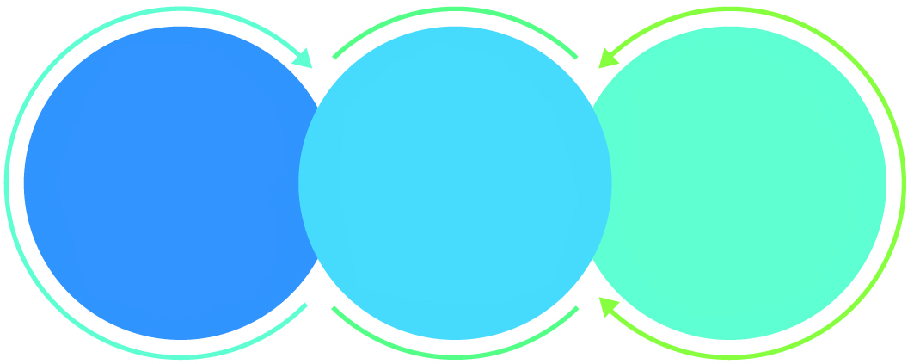

01

Agile development offering reliable, secure solution

02

Smooth transition and quicker completion of processes

03

User friendly interfaces enabling easy navigation between screens

## Why Verbat

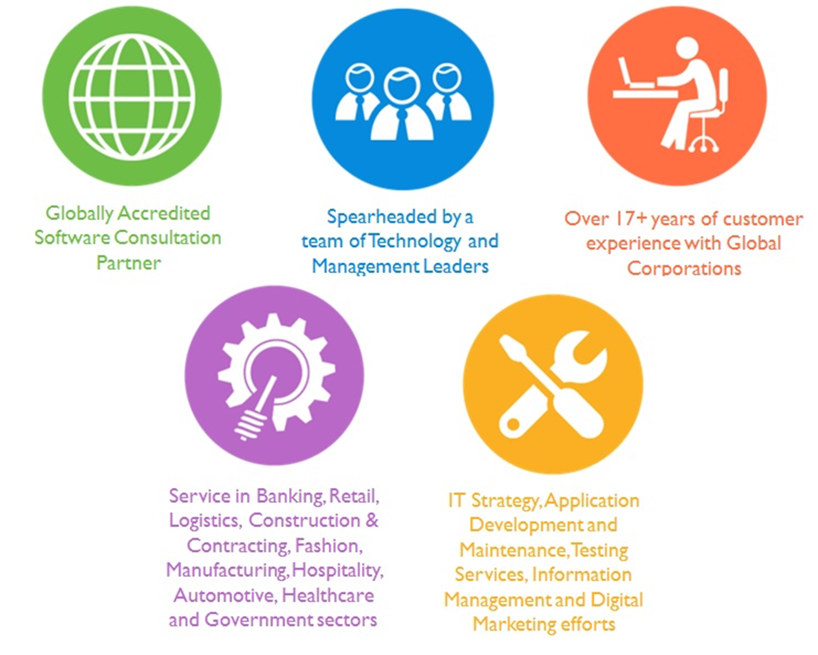

## Key Differentiators

Delivered digital transformation expertise to global customers for over a decade by following industry best practices to maximize ROI for client

Keen technology intelligence combined with aggressive market research to deliver solutions that achieve results with measurable value

Enable access to global consulting expertise with strong local market and business knowledge

Commercial Model that is customizable for your business needs

Services that are designed to optimize applications for improved performance and overall efficiency

1,000,000 plus man-hours of expertise in technology frameworks spanning Microsoft, Open Source, mobility platforms and other proprietary IT technology

Partners top technology vendors to bring in the latest and best services in integration, collaboration, and development

Commercial Model that is customizable for your business needs

Proven Methodologies & Processes

Investment in R & D

Strong Local Presence

Flexible commercial Models

Technology Associations

Software Development Experience

Offshore Development Centre

Quality Assurance & Testing

## Technology & Services

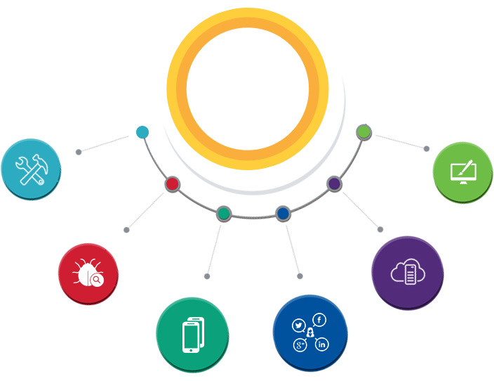

Technology  
&  
Services

Cloud/Traditional Hosting

User Interface & Design

Digital Marketing

Mobility Solutions

Testing Services

Application  
Development

# Functional Specification

## Site Design & Development

|  |
| --- |
| **Inception(MDM)** |
| create card series |
| Create Coupons |
| Reward Card Integration (with reader) |
| Scan Barcodes |
| Create Properties |
| **Customer (Mobile App + API)** |
| Customer card registration |
| Customer dashboard |
| Points redeemed |
| Rewards availed |
| Points available |
| Rewatds available |
| Soft copy of card |
| Coupons |
| Discounts |
| Feed Back / Complaints |
| Compliant resolution / In box |
| View Property with details (features, restaurants, menu etc.) |
| Order Concierge services |
| Newsletter, Static pages (3) |
| **Front Desk** |
| Issue new Card |
| Issue Duplicate card |
| Renew Card |
| Resolve Complaints |
| View Customer Purchase History |
| Issue Discounts |
| Process coupons |
| View Purchase History |
| Recommend services or products based on purchase history |
| Upsell / Cross sell |
| View Member details + customer look up |
| **Back Office** |
| Resolve complaints / Issues |
| Update customer Information + customer look up |
| Create Newsletters |
| Manage coupons (price, product, discount etc.) |
| Create Users , Set preferences |
| Assign roles |
| Create card Series |
| Manage Properties (Restaurants, menu, Concierge services, Room types, Banquet facilities, Conference rooms etc.) |
| **Management** |
| Parameterized reports to |
| Track purchases |
| Rewards availed |
| most Points awarded for category |
| Customer profiles |
| Set rewards system |

# High Level Solution

## High Level System Architecture

The short version of the architecture described are

* Static and dynamic data cached up front on varnish
* Even though Nginx can handle L7 load balancing, Perlbal offers better flexibility with its plugin system
* Jetty application servers easily scale out by using memcached as the session store
* Write intensive operations are done asynchronously via the ActiveMQ message store system
* One SQL database on RAID1 with a hot standby database on a third disk.

The architecture above can handle 6000+ request per second, however it can be scaled out to accommodate higher orders of traffic

Figure 2 High Level Technical Architecture

Figure Overall Workflow

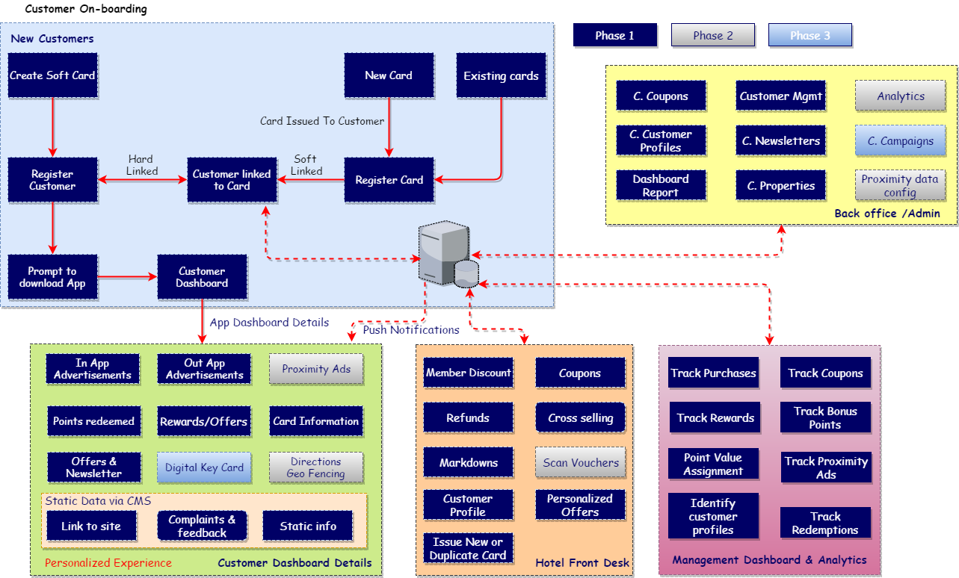

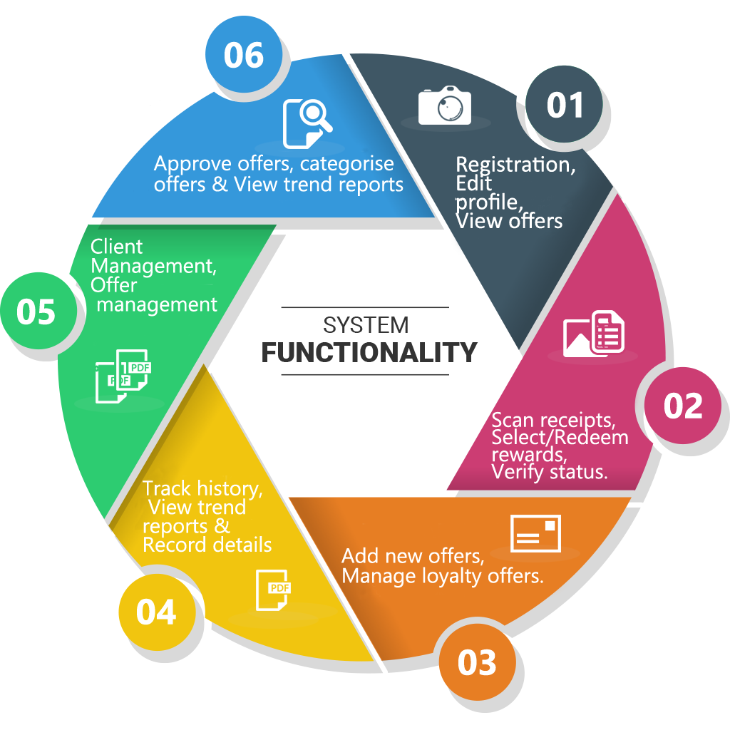

The image above is a conceptualization of the search algorithm described by the client. Keywords are analyzed for etymology, context, geographic information and relevance. The package definitions are applied over the results to derive the final result. Search keyword results are attributed with additional information such as business, map, and context etc. using stylized icons. Search results are interpreted differently for desktop and mobile devices.

## System Architecture

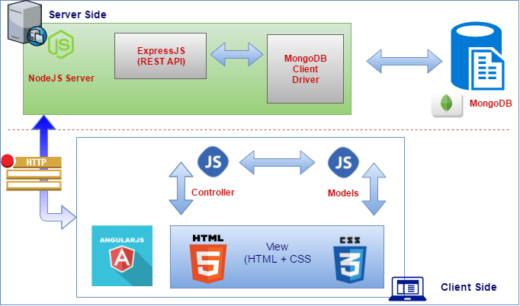

The proposed architecture uses a JavaScript based web application stack popularly known as the MEAN (Mongo DB, Express, Angular & NodeJS) stack.

Angular is a Single-Page Application (SPA), a Web app that loads a single HTML page and dynamically update that page as the user interacts with the app. SPAs use AJAX and HTML5 to create fluid and responsive Web apps, without constant page reloads.

In the MEAN stack NodeJS is JavaScript based server. Node.js is a fast and scalable network application. Node.js uses an event-driven, non-blocking I/O model that makes it lightweight and efficient, perfect for data-intensive real-time applications that run across distributed devices.

Express.js is a Node.js web application server framework, designed for building single-page, multi-page, and hybrid web applications. It is the de facto standard server framework for node.js. Express enables you to easily create web applications by providing a slightly simpler interface for creating your request endpoints.

MongoDB stores data in JSON-like documents that can vary in structure. Related information is stored together for fast query access through the MongoDB query language. MongoDB uses dynamic schemas, meaning that you can create records without first defining the structure, such as the fields or the types of their values.

The technology stack proposed above uniquely qualifies for the stated requirements of speed and versatility. The dynamic nature of MongoDB schemas lends itself to the requirement as each business can have its own unique business constraints.

# Nonfunctional Requirement (Others)

|  |  |
| --- | --- |
| **Requirement** | **Details** |
| User Experience and  UI Design | * The application will be developed only in English and Arabic * The layout and graphical components will be created considering the usability factors |
| Performance | * Application will allow users to have smooth and quick access to the information or services they require. |
| Security | * The system will be protected against attempts of security breaching that may arise. * Web security standards will be followed. |

# Assumptions

The project solution and technology is created from the initial understanding of the requirement shared with Verbat through mails and meetings. The proposed solution is based on the following assumptions:

* Client to provide Verbat with the branding guidelines.
* The proposed application will be bilingual (English & Arabic)
* Client will purchase the necessary templates needed for development
* Client shall provide licensed images and logos in specified size & format
* Requirements should be well defined, agreed and signed-off by the client
* Internet connectivity is required for the functioning of the web application.
* Customer will procure templates, SSL certificates & Payment processor
* Client will procure Site catalyst
* Client will procure Ad-Management server
* Client will provide access (API) to aggregation sites
* Client will provide access to third party integration services
* Client will provide API access and API’s for map integration
* Client will procure SMS gateways
* Testing will be done in latest versions of Google Chrome, Mozilla, Safari, & Edge web browsers only
* Development Contingent upon timely feedback from client
* UI effort is based on the impression that client will need a custom designed pages for unique content (as opposed to development based on procured templates). Design effort may be reduced by half if the design is based on templates

# Out of Scope

Following are considered to be out of scope while creating this proposal.

* Purchase of images, fonts
* Adding new features to the application other than mentioned in the functional specification.
* Any language other than English & Arabic
* Manual data entry
* Hardware Integrations / procurement and purchase
* Database migration
* Content writing
* Content or image procurement or uploading or editing.
* Hosting Infrastructure and Maintenance
* Annual Maintenance of the application (Bug fixing, debugging) - For AMC details, please refer section titled “Maintenance and Support”
* Physical deployment at client’s site
* Backup solution and Disaster recovery

# Technology Solution

## Proposed System Environment

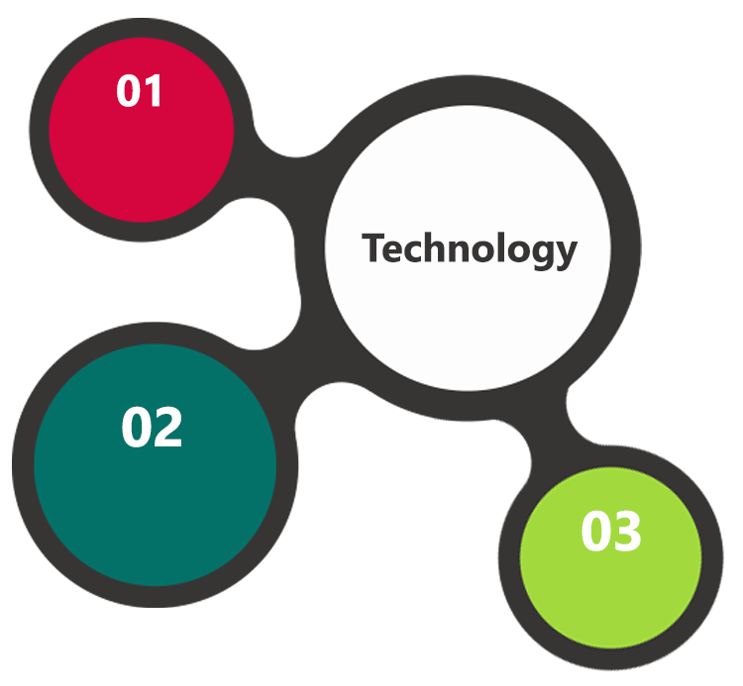

NodeJS, Express, MongoDB

Angular

HTML / CSS3/ Jquery

**MS SQL2012  
Windows 8/10  
Web Services**

## Technical Configurations

### Development Tools

* MVC, Angular
* NodeJS, Express JS, MongoDB
* HTML / CSS 3
* Ajax, JavaScript, JQuery

### Recommended (minimum) Web Hosting Package

* OctaCore CPU
* RAM: 32 GB
* MongoDB Enterprise Advanced
* Disk Space: 1 TB
* Monthly Bandwidth: 20 TB
* Web site Server Software – Apache

### Browser Compatibility

* Chrome version: 56
* Firefox version: 51
* Edge version: 39
* Safari version 10.1

### Hardware Interface

**Desktop**

The application is reliant on hardware interfaces to provide a seamless automated user experience.

* Computer with Windows 8 or 10 OS
* Compatible Browsers as specified in section 7.2.3

### Third Party Licensing

* Adobe Site Catalyst or Google analytics
* TomTom Maps – API
* Payment Processors
* Integration with Existing ERP or CRM applications
* API for aggregation sites
* SMS gateway integration
* SSL certificates
* Subscription to Android play store and IOS App Store
* API for affiliate marketing (zomato etc)
* Access to partner sites (including API and communication protocols)
* Real time chat interfaces with audio or video like Zoom.us

# Commercials

## Web Application

|  |  |  |
| --- | --- | --- |
| **No** | **Description** | **Amount (USD)** |
| 01. |  | 00,000.00 |
| 02. |  | 00,000.00 |
|  |  |  |

*Note:*

* *The above cost does not include Application hosting, integration, Project Management or deployment*
* *For change management cost, please refer to section 10 titled Change Management*

## Payment Terms

*Note: Payment should be made within 7 days from the date of the invoice*

## Mode of Payment

By Cheque / DD to Verbanet Technologies LLC

OR

Wire transfer to our bank account

Bank Name : Emirates NBD

Account Name : Verbanet Technologies LLC

Account Number : 1011492858201

IBAN Number : AE61 0260 0010 1149 2858 201

Swift Code : EBILAEAD

Bank Address : Mamzar Branch, Dubai

*Note: Bank charges incurred during wire transfer to be borne by the client. Any local taxes applicable to be borne by the client*

# Delivery Management

## Project Management

The Verbat development center strictly follows industry standards on quality. The project management is process governed by the Verbat Quality Management system and is put to verification through internal audit programs that happen from time to time.

Verbat will dedicate a project manager for the proposed implementation. Verbat proposes Client to identify one project manager who will be driving activities to be undertaken by Client to be the single point of contact for Verbat.

## Roles and Responsibilities

Verbat will assign a dedicated Project Manager/Project Lead to lead the project, who will be the first point contact for Client. He/she will be responsible for planning and managing the various activities within the project. He/she will work closely with Client Project Manager, to give periodic status updates and ensure high level of visibility and comfort on the progress of the project.

The Project Manager/Project Lead will lead the co-ordination between Verbat and Client, thus enabling smooth transitioning of Client requirements to the Verbat’s offshore delivery team, and provide visibility as well as comfort on the progress of the services to Client.

He/she will have periodic meetings with Verbat’s Senior Management, thus ensuring Verbat’s Management commitment and focus on Client initiatives.

## Delivery Activity Summary

|  |  |
| --- | --- |
| Activities | Description |
| Detailed requirement Analysis | Verbat team to conduct detailed study of requirement for the phase. If clarification is required, team will reach out to Client for more information and/or time for discussions. |
| DB Design | DB design for central and test DB. |
| Software Requirement Specification document (SRS) | Once the requirement analysis is completed, Verbat team will submit the SRS document for approval |
| UI/UX Design, Prototyping | Based on the SRS, Verbat UX/UI team will work on the UI/UX of the screens and submit a prototype for approval |
| Functional Specification Document (FS) | Once the Prototype. UI/UX is approved, Verbat shall submit an FS document for approval. |
| Development | Actual system development starts based on the FS. This involves detailed design and software development of Web Application. |
| Testing | Test Planning, test plan creations, internal, integration testing and user acceptance testing. |
| Deployment | Deploying the latest built in the Verbat Test Server. |

## Project Implementation Plan

Verbat will be providing the solution in a stand-alone fixed bid approach which ensures minimum viable solution for quick wins with core focus on the long-term business objective and outcome. Once the implementation is over, Verbat will initiate the application maintenance process (once the maintenance contract is signed) which continues to extend after the implementation.

## Deliverables

* Scope Document
* Project Plan
* Design templates
* Functional Specification Document
* Prototype of the application
* Test Plan Document
* User Manual
* Source Code
* Fully Developed & Tested Application

## Estimated Delivery Time

The effort estimated for delivering the application is as follows;

|  |  |  |
| --- | --- | --- |
| Phase | No of sprints | Total Man Days |
| System Study | 1.5 | 54 |
| Phase 1 | 3 | 510 |
| Phase 2 | 3 | 535 |
| Phase 3 | 2 | 119 |

|  |  |  |  |  |  |  |  |  |  |
| --- | --- | --- | --- | --- | --- | --- | --- | --- | --- |
|  | **Sys Study** | Phase 1 | | | Phase 2 | | | Phase 3 | |
| Resource | 1.5 Months | Sprint 1 | Sprint 2 | Sprint 3 | Sprint 4 | Sprint5 | Sprint 6 | Sprint 7 | **Sprint 8** |
| Project Manager | 4 | 7 | 10 | 5 | 11 | 10 | 5 | 3 | 3 |
| Business Analyst | 15 | 5 | 12 | 5 | 16 | 10 | 0 | 0 | 5 |
| UX | 25 | 10 | 15 | 3 | 25 | 15 | 2 | 1 | 1 |
| App Arch | 2 | 8 | 5 |  | 8 | 5 |  |  |  |
| DB Arch | 1 | 5 |  |  | 6 |  |  |  |  |
| Tech Lead | 3 | 15 | 10 | 5 | 18 | 10 | 5 | 0 | 0 |
| Sr. Dev |  |  | 25 | 20 |  | 20 | 20 | 0 | 0 |
| Developer |  |  | 80 | 80 |  | 80 | 80 | 10 | 10 |
| Android |  |  | 20 | 15 | 15 | 8 | 13 | 10 | 10 |
| IOS |  |  | 20 | 20 | 15 | 20 | 15 | 10 | 10 |
| QA Manager | 4 | 7 | 8 | 8 | 8 | 7 | 6 | 3 | 3 |
| QA |  | 5 | 20 | 62 |  | 20 | 62 | 20 | 20 |

* **20 UAE working man days per sprint**
* **Days for the development of the application from the Date of Approval of the Project: 6 working man months**

## Deliverables

Development will be split into 2 phases. Each phase split into 3 sprints each with a concise description of items that will be delivered for each sprint. The deliverables for each sprint will be dictated by the client.

The list below is a brief overview of the items that will be delivered mainly for referral purposes. The actual items delivered will be vary based on the decisions made at the time.

### Phase 1 Web

|  |  |
| --- | --- |
|  | Description |
| 1 | Home page and home page sections |
| 2 | Application framework |
| 3 | Application prototype and design |
| 4 | CMS integration for header and footer links including page content |
| 5 | Search results page |
| 6 | Business profile pages |
| 7 | Customer registration via social media with address details / login |
| 8 | Business registration and profile creation / login |
| 9 | Admin dashboard ( add customers, business, editors, publishers) |
| 10 | Publishing workflow |
| 11 | Search bar features |
| 12 | Implement search logic |
| 13 | Implement ad placement basic logic |
| 14 | Implement SEO |
| 15 | Basic map implementation with directions |
| 16 | Admin: Category management |
| 17 | Basic coupon management |
| 18 | Time bound advertisements |
| 19 | API development |
| 22 | Authentication, authorization, logging, auditing |

### Phase 1 & 2 Mobile (IOS & Android)

|  |  |
| --- | --- |
|  | Description |
| 1 | Login/ signup |
| 2 | Hamburger menu |
| 3 | Search bar with location enable |
| 4 | Search results |
| 5 | Profile page |
| 7 | Maps |
| 8 | Navigation with directions |
| 9 | Ad placement placeholders |
| 10 | Click to action |
| 11 | Newsletter subscription, service or product subscriptions |
| 12 | List view |
| 13 | Frequent searches |
| 14 | Reviews |
| 15 | Mobile app prototype & Design (Android & IOS) |
| 16 | In-App and Out-App notifications for coupons, discounts etc. |
| 17 | Vouchers with barcodes |

### Phase 2 Web

|  |  |
| --- | --- |
|  | Description |
| 1 | Site catalyst |
| 2 | Ad management server |
| 3 | Integration with Map (advanced features) |
| 4 | Integration with aggregation services |
| 5 | Integration with 3rd party services (booking, zomato etc) |
| 6 | Configuration of varnish and reports based on varnish |
| 7 | Redis configuration |
| 8 | Advertisement campaign management creation and set up |
| 9 | Bilingual web site |
| 10 | Fuzzy logic, word stemming, synonym recognition |
| 11 | Approval workflow advanced features |
| 12 | CRM related workflows |
| 13 | Archival and Cron jobs |
| 14 | Various reports for advertisers |
| 15 | Reports for connect.ae |
| 16 | Campaign management features for advertisers |
| 17 | API management |
| 18 | Syndicating search results as a service |
| 19 | Approval workflow for advertisers |

### Phase 3

Phase 3 will involve testing (functional, regression, load) of the product along with bug fixes (Android, IOS & Web).

## Release Planning

* Client will be informed about the release date and time through email.
* Client performs the UAT

## Risk and Contingency Planning

Verbat has identified various risk factors associated with this assignment and understands the impact of these risk factors on the project schedules. The objective of this section is to highlight for both Verbat and client, the risk factors, to analyze the impact of the risks on project execution, and to propose strategies to control and reduce the impact of the risk factor.

These various risks, which could arise during the project, are tabulated below along with mitigation implementation.

| Type of risk | Impact | Risk Mitigation | Risk Handling |
| --- | --- | --- | --- |
| Scope Creep | H | Functions and features will be detailed in system requirement documents and will go through client approval. Once this document is approved, any change to requirement will go through change management review for possible impact assessment. | Proper change management procedure will be implemented. |
| Delay in customer feedback | H | The plan is prepared with enough lead-time for customer reviews and approvals.  The customer is indicated with the dates when the document is expected after review and approval. | The request for feedback will be escalated if not attended at the right time so that the schedules are not affected. Deemed acceptance criterion is set up front and will be followed. |
| Non-availability of necessary software’s, frameworks, database instances and infrastructure at client’s hosting environment(If hosting support is provided by Verbat) | M | Client will be informed in advance on these requirements. | Possible impact to schedule. |
| Manpower attrition | L | All efforts would be made to ensure process dependence rather than being person dependent. As a risk mitigation plan Verbat will train backups. | A new person will be identified as early as possible, provided the required project-specific training and mentored by the senior members of the team to minimise impact of attrition on the project. |

*H-High, M-Medium, L-Low, NA-Not Applicable*

# Change Management

Any addition which comes out of the project scope, upon and after the launch of the tool will be considered as change management. Verbat recommends the following change management procedure for the same.

* Any change which comes out of the project scope, which was discussed, documented, and mutually approved by both the parties in the requirement stage, will be carried out only through raising a change request.
* Change request will be studied and an impact analysis on the existing work flow will be performed.
* On finalizing the impact, effort estimation for the change will be calculated and raised as additional requirement.
* Verbat will initiate the change request only after getting a formal approval from the client for the additional changes raised.
* Any change from the scope will be charged at **USD ----- per man day effort** and approval from the clients will be availed before commencing on any change management.

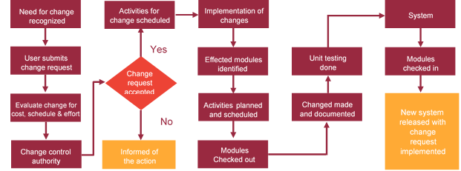

# Miscellaneous

## Acceptance Criteria

* UAT sign off should happen within 14 Days from the release of the application/ Phase and the acceptance confirmation needs to be mailed to Verbat failing which Verbat will consider the project as approved by the client.
* Any comments or reason for rejection need to be documented and the same needs to be sent as an email from the official mail id of client to Verbat.

## General Terms and Conditions

* All the projects activities will be carried out from our off-shore development center in India
* The scope of the project is to develop the Application as detailed in the scope of the project and mentioned in this proposal. Any changes or additions will have to go through change management.
* This proposal and all technical/ functional specifications have been derived or concluded from the data shared via email / information's transferred during the initial requirement analysis meetings and conversations. Verbat reserves the right to amend the terms of this proposal, should the SOW terms, functional features and functionalities change during the course of the project
* Application will be best viewed only in the environment mentioned in this document
* All the documentation will be provided in English.
* Third party components may be used to develop this application.
* All Source Code and other project artefacts would adhere to the Verbat document templates and internal coding standards
* Client shall provide the respective enterprise apple store and Google play store accounts for development and production
* Acceptance criteria shall be based on the clauses which were mutually discussed between Verbat and client at the Requirement Analysis phase and the same will be documented and approved by both parties through official emails
* In case Client requires any extension of the proposed acceptance schedule, the associated effort and cost of such extension can be mutually reviewed.
* For any circumstances if project needs to be put on Hold / Stop it requires minimum request notice period of 2 weeks along with duration for which request will be addressed by management and final decision on the request will be based on that
* If deployment is done in client’s server, Verbat cannot be held responsible for any performance issues arising due to hardware malfunctions.
* Source code will only be delivered or uploaded on the Production Server once the due payments are made.

## Assumptions and Dependencies

* Detailed system study is required before the start of the project.
* During the requirement gathering phase, authorized personnel from the Client’s side is expected to be available for discussion and finalizing the HLD (High Level Design), before development commences.
* Type of reports and formats, if under the scope of the project, needs to be specified by Client before project sign off.
* Workflows if under the scope of the project, need to be specified/ confirmed by client before project signoff.
* All queries regarding the client requirement and any queries which may hinder the project advancement at any stage should be answered by the client within 24 hours from the time of initiation, failing which the time delay will get added to the actual effort which was estimated.
* Verbat assumes that all sign-offs from Client will be provided within agreed and specified timeframe.
* Client will provide all the necessary contents, both text and image, before starting the project in the format suggested by Verbat (if any).
* The client should provide the relevant information and data well in time for the execution of a related activity. Non- availability of this information or data may lead to an interruption of work which may result in a delay in delivery as well as additional costs to the client.

## Source Code & Intellectual Property Rights

* Upon completion of the Project and 100% completion of the payment, client will have access to the source code except for propriety codes, developer tools and third party application etc.
* The solution offered will be the intellectual property of the client and will be made available to the client on an “unlimited license” basis.
* Modifications by third party/person: No person or organization, other than Verbat or any person authorized by Verbat in writing, has any permission to modify/change the software Solution to be eligible to get continued support from Verbat as per the support terms defined under this document.
* Liabilities/Damages: Verbat accepts no liability or damages of any kind arising out of use or non-use of the software delivered. The responsibility of testing of software lies with Client.

## Maintenance & Support

* Maintenance contracts by default are supported as per the basic SLA terms.
* **AMC with Basic SLA is charged at 20 % of the total project value**. Additional Effort/change management request will be added towards Total Value of the Project to determine the AMC value.
* Maintenance support is limited to providing application support for ensuring the consistency of the look-and-feel, bug fixes and user issues i.e. maintenance and support of the existing features of the application.
* Support does not in any way cover providing technical or other support to the end users. The maintenance agreement does not include functionality changes or feature additions which are handled as change requests which will be charged AED 1200 per man day. AMC does not include server support, maintenance and application deployment.
* AMC charges will cover Off-Site Support and Debugging. Support includes E-mail, Telephone and Chat unless explicitly specified. In the event, the application is hosted with the client; necessary remote desktop connectivity should be provided for carrying out maintenance activity.
* Gap in AMC - In case if the client does not opt an AMC for a year and want to renew it after that period, 50% of the AMC amount for the year for which AMC is not taken will also be payable if the client wishes to renew the AMC contract.
* Note:
  + Please note that the AMC support shall start only after all the necessary sign-offs (AMC Document) to this effect have been given.
  + It is not mandatory that the client should opt for an AMC. The client will still be supported on an ad-hoc basis on an agreed man-day rate.
  + AMC Payment Terms: 100% to be paid as advance.

## Service Level Agreement

|  |  |  |  |  |
| --- | --- | --- | --- | --- |
| **Key** | **Max Response Time** | | **Max Resolution Time** | **Target** |
| Basic | 1  working day | 3 working days | | Request / incident / problem tickets |
| Advanced | 5 Business Hours | 12 Business Hours | | Request / incident / problem tickets |
| Priority | 3 Business Hours | 5 Business Hours | | Request / incident / problem tickets |

Note:-

* We provide Basic SLA as standard with AMC while Advanced and Priority SLAs attract additional charges.
* Time zone applicable as per India time zones (3:30 AM GMT to 12:30 PM GMT- Monday to Friday).

# Our Clients

**UAE University**

Education

Transportation

**Canada Cartage**

Construction

Services

Finance

We look forward to hearing from you soon and hope that you will give us the privilege to work with you in meeting your business goals. Thank you.

Thank You



©   
1999 - 2017. All Rights Reserved   
Verbanet Technologies LLC  
www.verbat.com